Geethika V K
23MIS0252
Question:

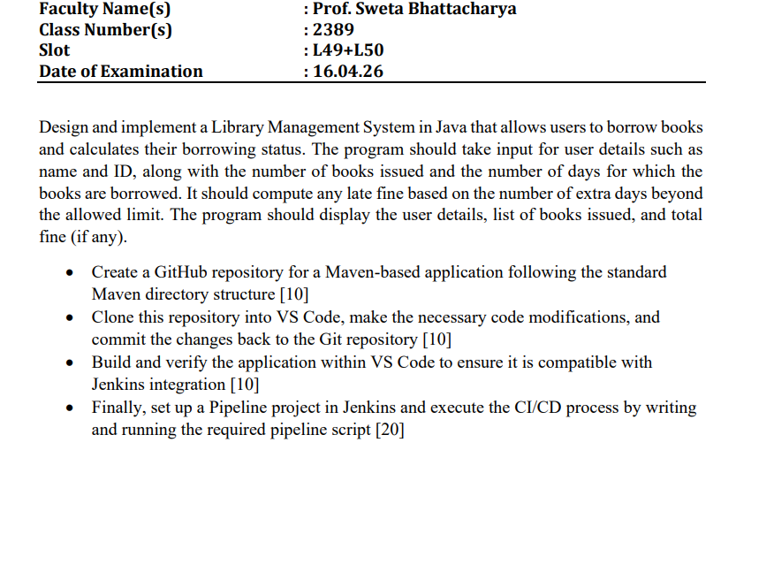

Folder Structure:
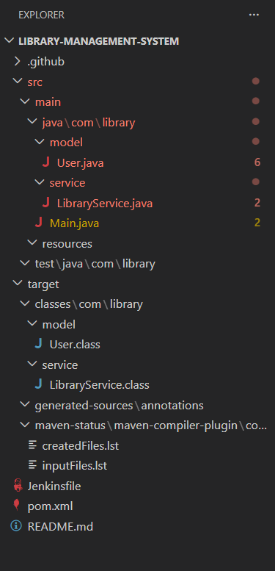

Source Codes:
User.java
package com.library.model;

public class User {

private String name;
private String id;
private int booksIssued;
private int daysBorrowed;

public User(String name, String id, int booksIssued, int daysBorrowed) {
this.name = name;
this.id = id;
this.booksIssued = booksIssued;
this.daysBorrowed = daysBorrowed;
}

public String getName() {
return name;
}

public String getId() {
return id;
}

public int getBooksIssued() {
return booksIssued;
}

public int getDaysBorrowed() {
return daysBorrowed;
}
}

LibraryService.java

package com.library.service;

import com.library.model.User;

public class LibraryService {

private static final int MAX_ALLOWED_DAYS = 7;
private static final int FINE_PER_DAY = 10;

public int calculateFine(User user) {
if (user.getDaysBorrowed() > MAX_ALLOWED_DAYS) {
int extraDays = user.getDaysBorrowed() - MAX_ALLOWED_DAYS;
return extraDays * FINE_PER_DAY;
}
return 0;
}

public void displayUserDetails(User user) {
int fine = calculateFine(user);

System.out.println("\n===== User Details =====");
System.out.println("Name: " + user.getName());
System.out.println("User ID: " + user.getId());
System.out.println("Books Issued: " + user.getBooksIssued());
System.out.println("Days Borrowed: " + user.getDaysBorrowed());
System.out.println("Allowed Days: " + MAX_ALLOWED_DAYS);
System.out.println("Fine per Extra Day: ₹" + FINE_PER_DAY);

if (fine > 0) {
System.out.println("Total Fine: ₹" + fine);
} else {
System.out.println("No Fine ✅");
}
}
}

Main.java

package com.library;

import com.library.model.User;
import com.library.service.LibraryService;
import java.util.Scanner;

public class Main {
public static void main(String[] args) {
Scanner sc = new Scanner(System.in);

System.out.println("===== Library Management System =====");

System.out.print("Enter Name: ");
String name = sc.nextLine();

System.out.print("Enter User ID: ");
String id = sc.nextLine();

System.out.print("Enter Number of Books Issued: ");
int books = sc.nextInt();

System.out.print("Enter Number of Days: ");
int days = sc.nextInt();

User user = new User(name, id, books, days);
LibraryService service = new LibraryService();

service.displayUserDetails(user);

sc.close();
}
}

Jenikins File:

pipeline {
agent any

tools {
maven 'Maven3'
jdk 'JDK17'
}

stages {

stage('Clone Repository') {
steps {
git 'https://github.com/00geethika/library-management-system.git'
}
}

stage('Build') {
steps {
bat 'mvn clean compile'
}
}

stage('Test') {
steps {
bat 'mvn test'
}
}

stage('Package') {
steps {
bat 'mvn package'
}
}

stage('Run Application') {
steps {
bat 'mvn exec:java'
}
}
}
}

Pom.xml:

<project xmlns="http://maven.apache.org/POM/4.0.0"
xmlns:xsi="http://www.w3.org/2001/XMLSchema-instance"
xsi:schemaLocation="http://maven.apache.org/POM/4.0.0
http://maven.apache.org/xsd/maven-4.0.0.xsd">

<modelVersion>4.0.0</modelVersion>

<groupId>com.library</groupId>
<artifactId>library-management-system</artifactId>
<version>1.0-SNAPSHOT</version>

<build>
<plugins>
<!-- Compiler Plugin -->
<plugin>
<groupId>org.apache.maven.plugins</groupId>
<artifactId>maven-compiler-plugin</artifactId>
<version>3.11.0</version>
<configuration>
<source>17</source>
<target>17</target>
</configuration>
</plugin>

<!-- Exec Plugin to run program -->
<plugin>
<groupId>org.codehaus.mojo</groupId>
<artifactId>exec-maven-plugin</artifactId>
<version>3.1.0</version>
<configuration>
<mainClass>com.library.Main</mainClass>
</configuration>
</plugin>
</plugins>
</build>

</project>

Screenshots of Total Project Implementation:

